Directions: The goal of the following problems is to help challenge and deepen your understanding of the current topic. Don’t assume that you will know how to answer every question. You will work with at least two other students in the class to try and find solutions and write arguments for each of the following questions. Be sure that you question your classmates’ reasoning. If you don’t understand how they are getting something, you should ASK THEM TO EXPLAIN! Being able to defend your reasoning is important and so you are actually helping them by asking them to explain.

Challenge Questions

- Consider the graphs of and .
- The x-coordinates for the points of intersection are . Without a graphing utility sketch a picture of the region R determined by these curves and label the intersections points.

- Determine the area of the region R by integrating with respect to y.

- Determine the area of the region R by integrating with respect to x.

- Create a region (a picture suffices) where when finding the area of the region with respect to x two integrals are required and when working with respect to y three integrals are needed.

- Consider the region R defined by the curve and the x-axis. There exists a line of the form which will divide the area of this region in half. Determine the value of m.

- Suppose that a triangle is formed by the x and y-axis and a tangent line to where .
- Draw a picture of a possible triangle created using the above method.

- Show that for any value of the area of the triangle will be constant.

- Let S be the area of the region bounded by the curve and the tangent line to the curve at . If , where a and b are integers and is in simplest form, what is the value of ?

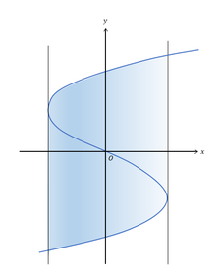
- If the blue curve in the diagram represents the graph and the vertical lines are tangent to the curve, what is the area of the shaded region?

